It is a kind of truism that whenever engineers need to explain their systems to each other they tend to resort to drawing pictures with boxes and arrows between them. For example:{\SCRV_FN=There are other systems of boxes and arrows that have utility. The most well-known example is probably the suite of diagrams that make up UML.\END_SCRV_FN}
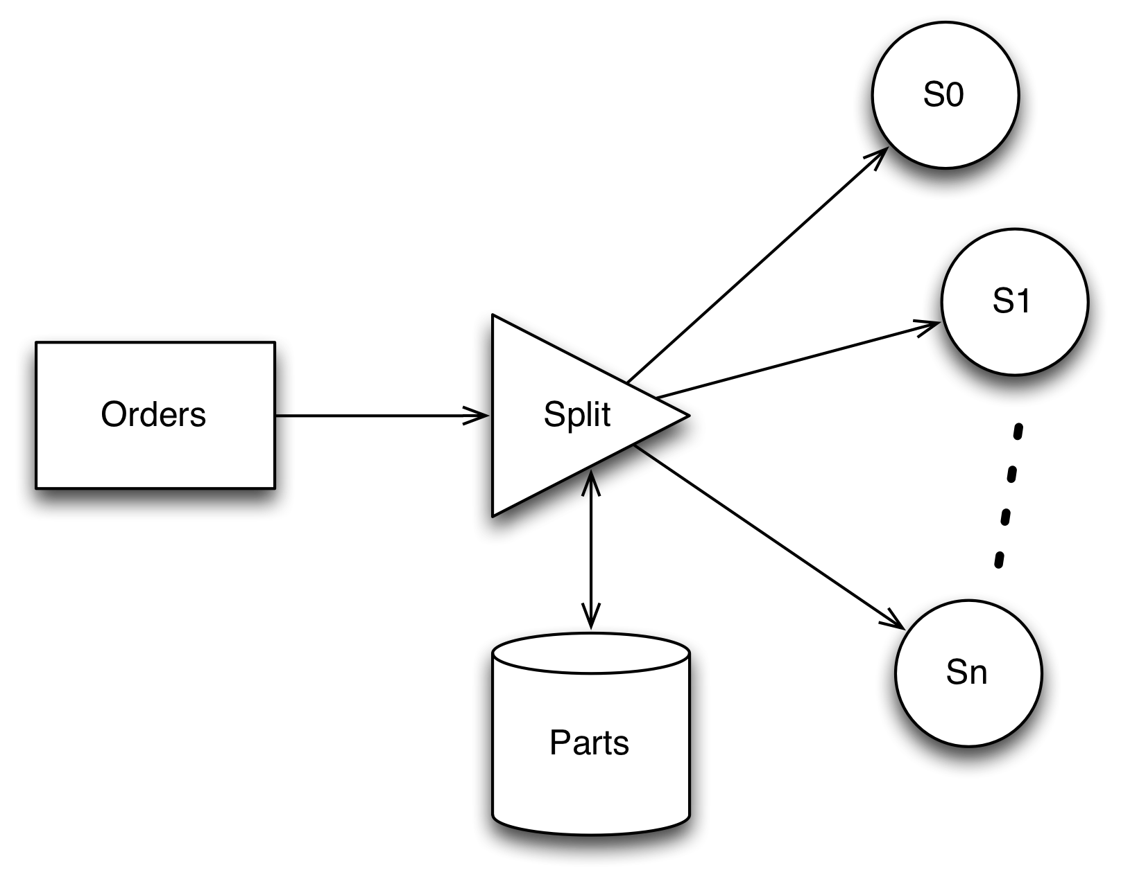
A System for Splitting Orders
could be used to explain the system for managing the way parts are ordered in a car factory that supported a ‘build-to-order’ model for manufacturing customized vehicles.
The different boxes show the major sub-systems and the arrows between them show the major flows between them: we have an input Orders sub-system that accepts incoming orders for cars, we have a Splitter that breaks up the orders into orders for specific assemblies and parts. We also have a Parts database that ‘knows’ how different order requirements translate into specific assemblies. The outputs of the system are orders for parts that will go to individual suppliers S~0~ through S~n~.
There have been a number of attempts to take the boxes-and-arrows intuition and turn it into something that is more actionable. Here, we take an approach that focuses on boxes representing components that denote areas of responsibility and where arrows represent interactions between the components.
In laying out our platform architecture, we tighten up on one rather important aspect of designing systems: all interactions between components are explicitly identified; and, in keeping with the Star style, all interactions are strongly statically typed.
For example, if we zoom in on the Split component above, and draw it in isolation we might arrive at:
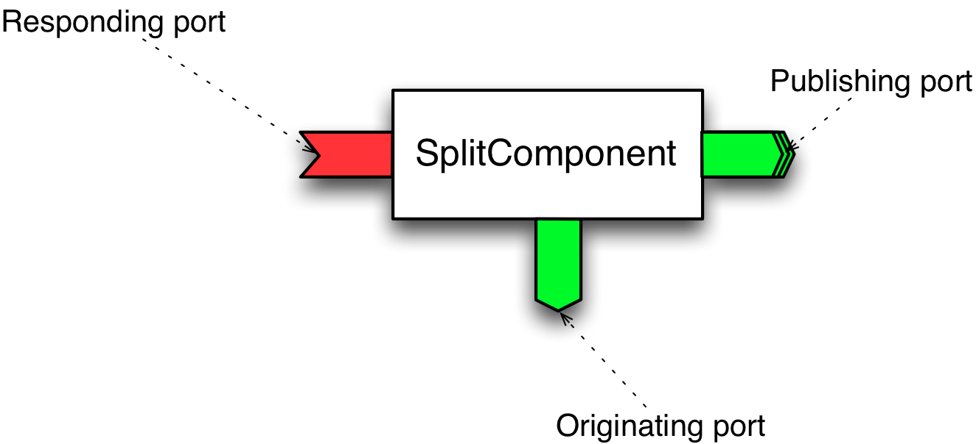
The Split Component
The main new feature in this diagram – compared to the informal version – are the different ports that represent the entry and exit points to components. The SplitComponent above has three different ports on it: a responding port that handles incoming orders, an originating port that will be connected to a database and a publishing port that will be connected to multiple supplier components. Given this diagramming notation, the order processing system would look something like:
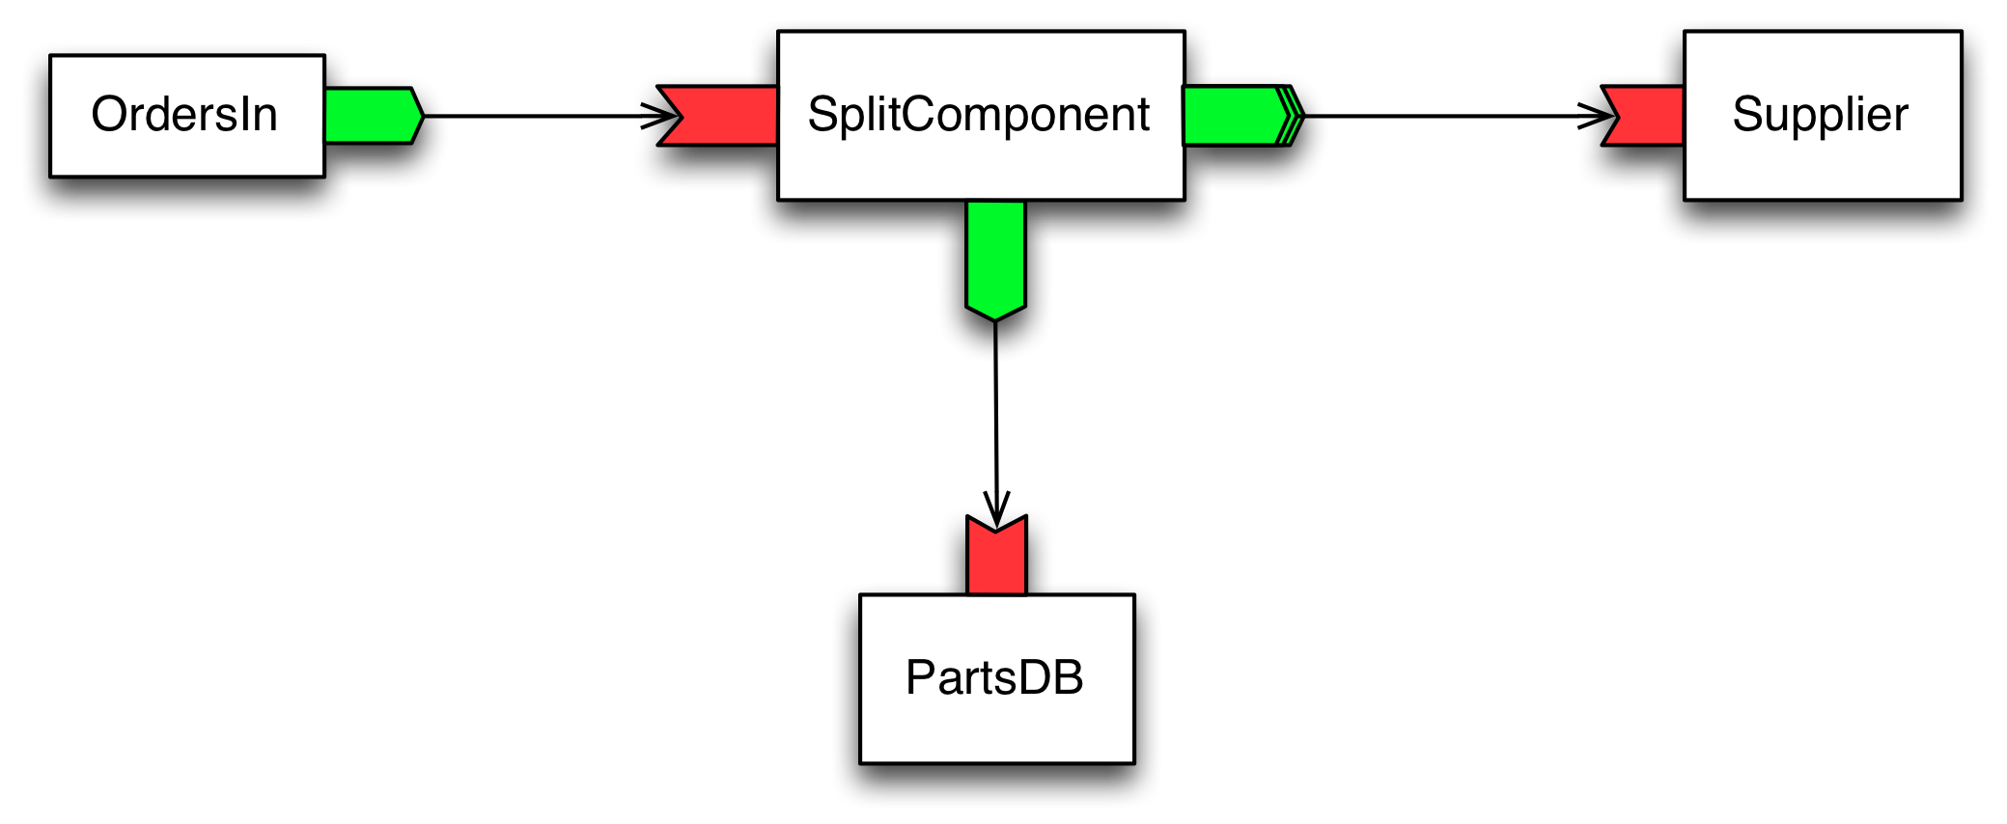
An Order Processing System
The main difference between this diagram and the original boxes-and-arrows picture is a slight formalization of the notation: we have crystalized the role of boxes (into processing components) and we have formalized the connections in terms of different kinds of ports.
In addition, we emphasize that the key architectural constraint that we adopt is that all communication between components should be explicit. Another way of stating this is that
wiring between components belongs to the containers in which the components are embedded.
Other aspects of platforms which would be necessary to complete the picture include the market place itself: how can clients select components for use in their applications and how can providers make their offerings known? We will come back to these questions below.
It turns out that, with some support from Star, we can turn diagrams like these into executable code that can be deployed over distributed systems. Let us see how we might go about this…

